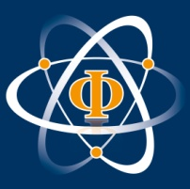
Introductory Course on Quantum Information
Innsbruck, 07-11 July 2014, including a colloquium of the Innsbruck-Vienna SFB “Foundations and Applications of Quantum Science (FoQuS)”
Organizers: Martí Cuquet (Univ. Innsbruck), Ben Lanyon, Adi Makmal (IQOQI, Univ. Innsbruck), and Innsbruck Physics Research Center
Application form (to be sent by May 30 2014)

Surname:

First name:

Home address:

E-mail address:

University:

Begin of physics studies:
year

BSc degree:
date or expected date, if applicable,
otherwise give date of pre-diploma or other exams

Name of recommending professor:

Diploma or Master thesis:
starting date or expected starting date

Travel support requested (yes\no): sd
maximum of 200€ available for each external participant yes no

Departure date (default is Friday, 11 July):
arrival date is Mon, 7 July for all external participants

Date and signature:

Please send your application to the Innsbruck Physics Research Center, Univ. of Innsbruck, Attn.: Ms. Nicole Jorda, sp-physik@uibk.ac.at or fax: +43 512 507 52492

